# Media Analysis - ChatGPT is the ‘Netscape moment’ for artificial intelligence’

## Short Summary

The article examines ChatGPT's substantial societal impact, likening it to Netscape's influence on the internet, while discussing its text generation prowess, misinformation risks, and the necessity for advanced common sense and reasoning capabilities it also delves into future AI advancements like foundation models and their potential economic benefits.

## Summary

1. **Opportunities in AI**: The article highlights the potential of Artificial Intelligence (AI), specifically Large Language Models (LLMs) like ChatGPT, to automate tasks previously done by humans, increasing productivity and reducing labor costs. This is particularly beneficial in economic times with inflationary pressures and rising labor expenses.  
2. **AI-Generated Content**: Law firms are exploring the use of AI for automatically creating contract skeletons, demonstrating how LLMs can generate text based on given prompts or starting points.  
3. **Content Creation Concerns**: There is a concern about AI-generated misinformation and plagiarism, as these models might produce highly plausible false content. This could potentially poison search engine results or mislead people in harmful ways.  
4. **Limitations of Current AI Models**: LLMs lack understanding of the world, common sense, and reasoning abilities. They can generate superficially plausible but entirely false information, known as 'hallucinations.'  
5. **Future Evolution of AI**: The article suggests that future advancements in AI will involve integrating systems that enable common sense, ethical reasoning, and understanding of the world, making models more human-like. This includes both fast, contextual thinking similar to LLMs' word recognition abilities and slower, logical, conscious thinking.  
6. **Foundation Models**: The concept of 'foundation models,' such as generative pre-trained transformers, is introduced. These can be trained once and then extended or reused widely at minimal cost, serving as a platform for new applications.  
7. **AI Adoption in Saudi Arabia**: Given the Kingdom's focus on data and AI development, coupled with efforts to train local talent and investments by national entities like Aramco, Saudi Arabia is well-positioned to leverage AI for future sustainability and prosperity. This includes localizing LLMs to regional languages and developing domain-specific foundation models based on the country's expertise in areas like energy.

## Question 1:

How do the media (in our case = the sample we are analyzing) frame the public discussion about ChatGPT? Are there certain **metaphors** that keep cropping up?

Netscape moment for AI

## Question 2:

Which role does the Arabic World play in the field of Artificial Intelligence in this article according to the author? Answer with 'Not mentioned' if not applicable.

Saudi Arabia is seen as exceptionally well-positioned within the Arabic World to leverage AI opportunities, particularly in localizing language models and leveraging domain knowledge.

## Question 3:

How helpful is Artificial Intelligence for the Arabic world based on this article?

The article suggests Artificial Intelligence, particularly large language models like ChatGPT, could be beneficial for the Arabic world due to its potential for language understanding and generation in various dialects. This capability could lead to applications such as customer service, content creation, or domain-specific knowledge extraction. Saudi Arabia's efforts in training local professionals and investments by national champions further position the region well to leverage AI technology.

## Question 4:

What is the final message of the article that the author wants to convey? Keep your answer short and precise!

The author underscores the transformative potential of ChatGPT and LLMs, advocating for their responsible development that incorporates common sense and ethics. He also highlights Saudi Arabia's advantageous position in leveraging AI for economic growth amid labor cost challenges.

## Sentiment

The sentiment is 0

## Entities

Arab News', GPT, AI Authority, Disclaimer Views, ANTHONY BUTLER, Aramco, AI, IBM, Anthony Butler, LLM, the Saudi Data, exempli ed, ChatGPT

## Topic Clusters

### Cluster: ChatGPT and Deep Learning

ChatGPT popularity, Deep learning

### Cluster: AI-generated Content and Misinformation

AI hallucinations, Misinformation production

## Word Clouds

### Wordcloud of content

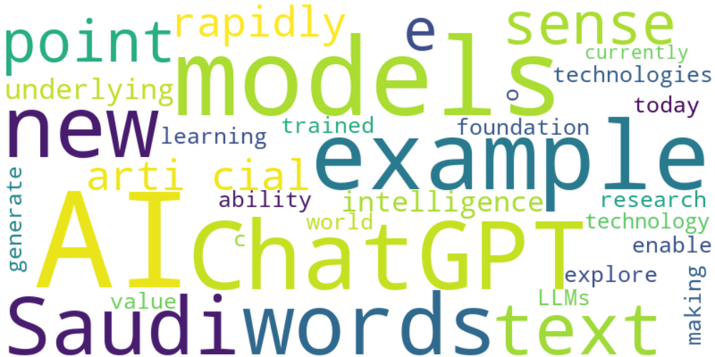

Top 10 words:

- AI: 13

- models: 8

- ChatGPT: 6

- example: 6

- new: 5

- words: 5

- Saudi: 5

- arti: 4

- cial: 4

- text: 4

### Wordcloud of summary



Top 10 words:

- AI: 11

- LLMs: 5

- like: 4

- models: 4

- Models: 3